**WEEK - 1**

**Problem**

Nitin and Sobhagya were playing a game with coins. If Sobhagya has **more** coins then he is *winning*, otherwise Nitin is winning. **Note** that this means if both Nitin and Sobhagya have the same number of coins, then Nitin is winning.

Initially Nitin has A*A* coins while Sobhagya has B*B* coins. Then Ritik came and gave his C*C* coins to the player who is **not winning** currently, after which Satyarth came and repeated the same process (gave his D*D* coins to the player who is **not winning** currently).

Find the final winner of the game.

**Input Format**

* The first line of the input contains an integer T*T* - the number of test cases. The test cases then follow.
* The only line of each test case contains four space-separated integers A*A*, B*B*, C*C*, and D*D*.

**Output Format**

For each test case, output on a single line N if Nitin is the final winner of the game, or S if Sobhagya is the final winner of the game.

**Solution :**

t = int(input())

for _ in range(t):

c = list(map(int,input().split()))[:4] **# coins**

if(c[0]<c[1]):

c[0] = c[0]+c[2]

else:

c[1] = c[1]+c[2]

if(c[0]<c[1]):

c[0] = c[0]+c[3]

else:

c[1] = c[1]+c[3]

if (c[0]==c[1] or c[0]>c[1]):

print("N")

else: print("S")

**Test Cases:**

**Input:**

3

2 3 4 5

3 3 3 3

2 3 1 2

**Output :**

S

N

S

**Result :**

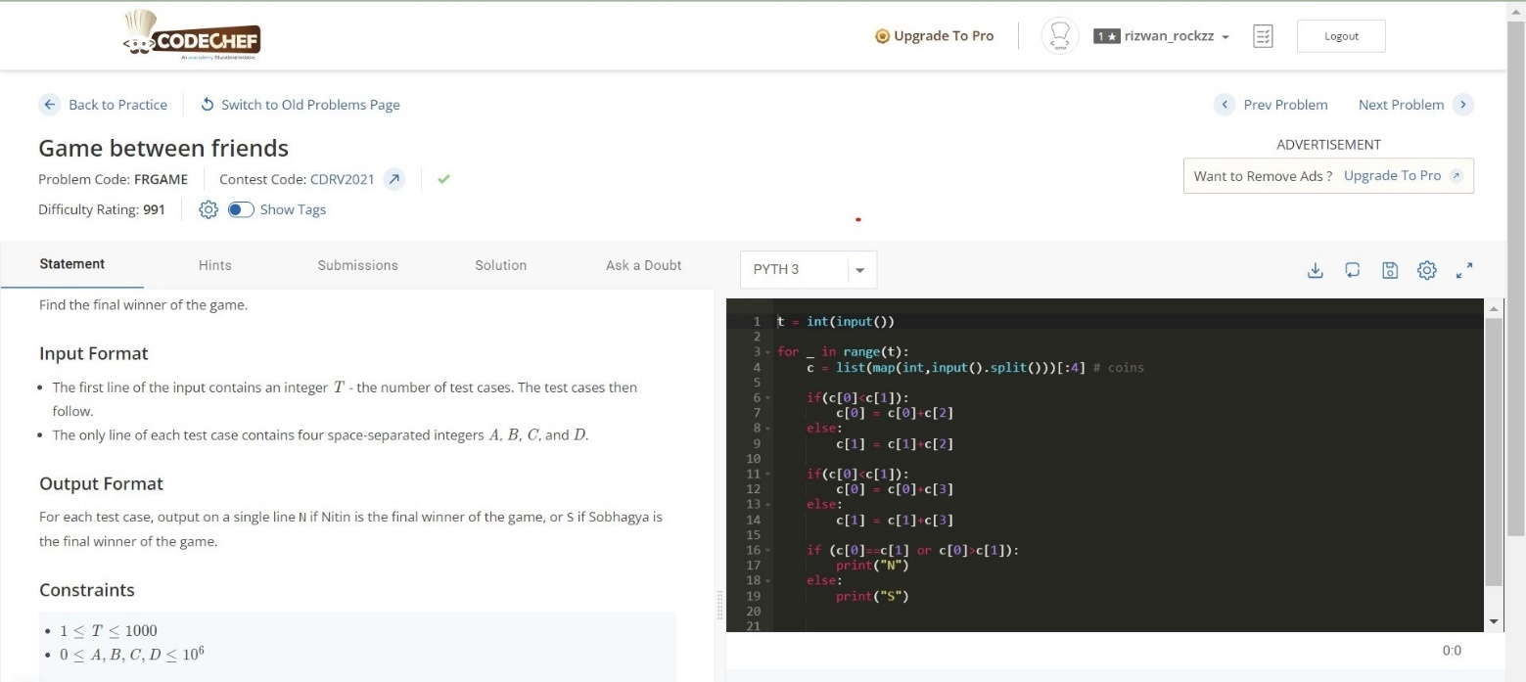

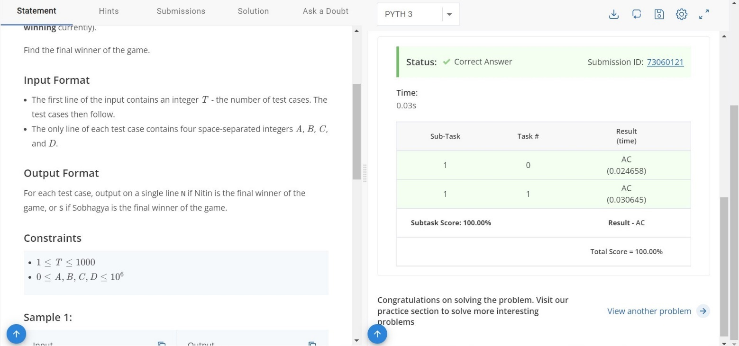

**Why only this DS is used? :**

This question is all about conditional statements (if, else) successfully executed.

**Time Complexity :** O(n)

**Space Complexity :** O(n)

**Result :** Successfully Executed the Program.

**WEEK – 2**

**Problem**

You are given a standard 8 \times 88×8 chessboard which has exactly 22 rooks on it and no other pieces. The rows are numbered 11 to 88 from bottom to top, and the columns are numbered 11 to 88 from left to right. The cell at the intersection of the i*i*-th column and j*j*-th row is denoted (i,j)(*i*,*j*).

Given the initial positions of the rooks in the form of coordinates (X_1,Y_1)(*X*1​,*Y*1​) and (X_2,Y_2)(*X*2​,*Y*2​), you need to tell whether the 22 rooks currently attack each other or not. Assume, each square can contain at most one piece.

Rooks can only travel in straight lines along the row or column they are placed at, and can't jump over other pieces. For a more detailed explanation of the moves of rooks, along with images, please [click here](https://en.wikipedia.org/wiki/Rook_(chess)#Placement_and_movement).

**Input Format**

* The first line contains T*T* - the number of test cases. Then the test cases follow.
* The first line of each test case contain four space-separated integers each X_1, Y_1, X_2, Y_2*X*1​,*Y*1​,*X*2​,*Y*2​ - (X_1,Y_1)(*X*1​,*Y*1​) is the position of the first rook and (X_2,Y_2)(*X*2​,*Y*2​) is the position of the second rook.

**Output Format**

For each test case, output on a single line YES (without quotes) if the rooks attack each other, and NO otherwise.

You may print each character of the string in uppercase or lowercase (for example, the strings YeS, YEs, yes and yeS will all be treated as identical).

**Solution :**

t = int(input())

for _ in range(t):

m = list(map(int,input().split()))[:4] # moves

if( m[0]==m[2] or m[1]==m[3] ):

print("YES")

else:

print("NO")

**Test Cases:**

**Input:**

3

2 3 4 5

3 3 3 3

2 3 1 2

**Output :**

YES

YES

NO

**Result :**

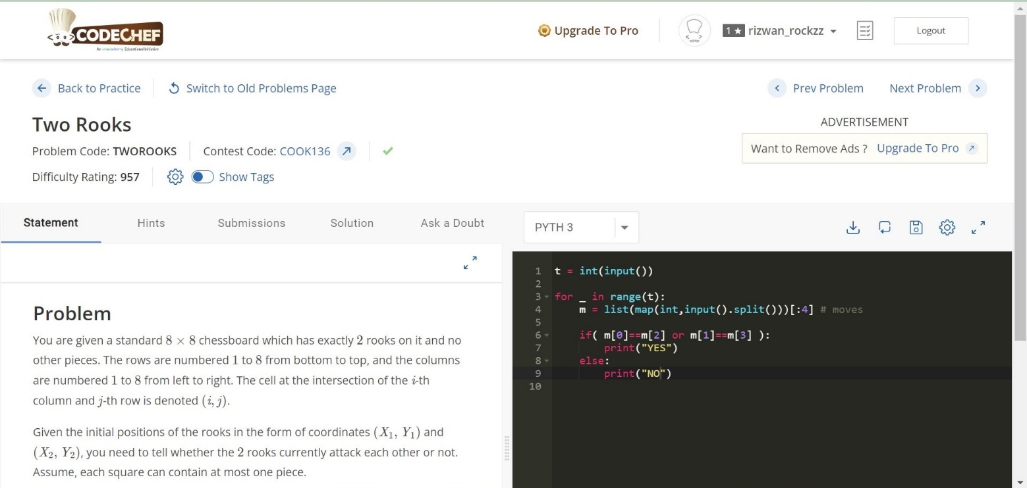

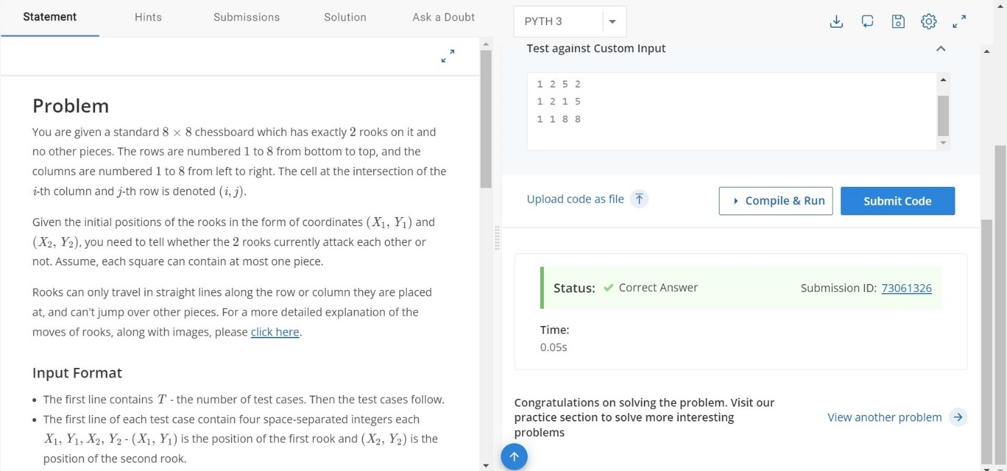

**Why only this DS is used? :**

This question is all about conditional statements (if, else) successfully executed.

**Time Complexity :** O(n)

**Space Complexity :** O(n)

**Result :** Successfully Executed the Program.

**WEEK – 3**

**Problem**

Suppose Chef is stuck on an island and currently he has x*x* units of food supply and y*y* units of water supply in total that he could collect from the island. He needs x_r*xr*​ units of food supply and y_r*yr*​ units of water supply per day at the minimal to have sufficient energy to build a boat from the woods and also to live for another day. Assuming it takes exactly D*D* days to build the boat and reach the shore, tell whether Chef has the sufficient amount of supplies to be able to reach the shore by building the boat?

**Input:**

* First line will contain T*T*, number of testcases. Then the testcases follow.
* Each testcase contains of a single line of input, five integers x, y, x_r, y_r, D*x*,*y*,*xr*​,*yr*​,*D*.

**Output:**

For each testcase, output in a single line answer "YES" if Chef can reach the shore by building the boat and "NO" if not (without quotes).

You may print each character of each string in uppercase or lowercase (for example, the strings "yEs", "yes", "Yes" and "YES" will all be treated as identical).

**Solution :**

for _ in range(int(input())):

x,y,x1,y1,d = map(int,input().split())

food = x/x1

water = y/y1

mindays = min(food,water)

# print(mindays)

# print(d)

if d<=mindays:

print("YES")

else:

print("NO")

**Test Cases:**

**Input:**

3

4 2 1 1 1

4 2 1 3 1

4 2 4 2 2

**Output :**

YES

NO

NO

**Result :**

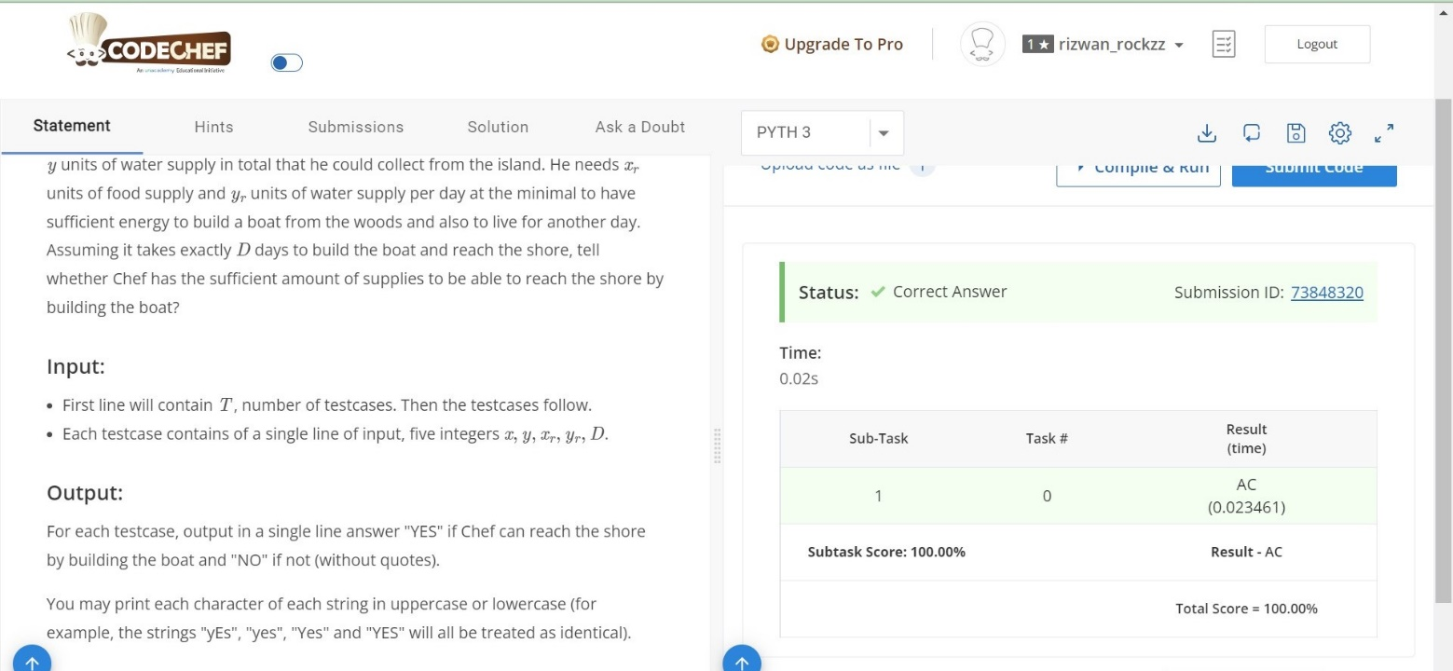

**Why only this DS is used? :**

This question is all about conditional statements (if, else) successfully executed.

**Time Complexity :** O(n)

**Space Complexity :** O(n)

**Result :** Successfully Executed the Program.

**WEEK – 4**

**Task 1**

**Problem**

Chef's son Chefu found some matches in the kitchen and he immediately starting playing with them.

The first thing Chefu wanted to do was to calculate the result of his homework — the sum of A*A* and B*B*, and write it using matches. Help Chefu and tell him the number of matches needed to write the result.

Digits are formed using matches in the following

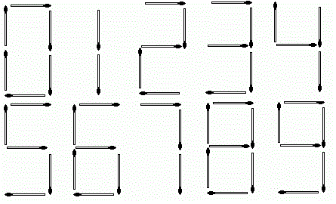

**Input**

* The first line of the input contains a single integer T*T* denoting the number of test cases. The description of T*T* test cases follows.
* The first and only line of each test case contains two space-separated integers A*A* and B*B*.

**Output**

For each test case, print a single line containing one integer — the number of matches needed to write the result (A+B*A*+*B*).

**Solution:**

**# cook your dish here**

nsticks = [6,2,5,5,4,5,6,3,7,6]

for _ in range(int(input())):

n = 0

a,b = map(int,input().split())

c = a+b

c = str(c)

# print(c)

for i in c:

# print("val[{}] : {}".format(int(i),nsticks[int(i)]))

n = n+nsticks[int(i)]

print(n)

**Test Cases**

**Input:**

3

123 234

10101 1010

4 4

**Output :**

13

10

7

**Result:**

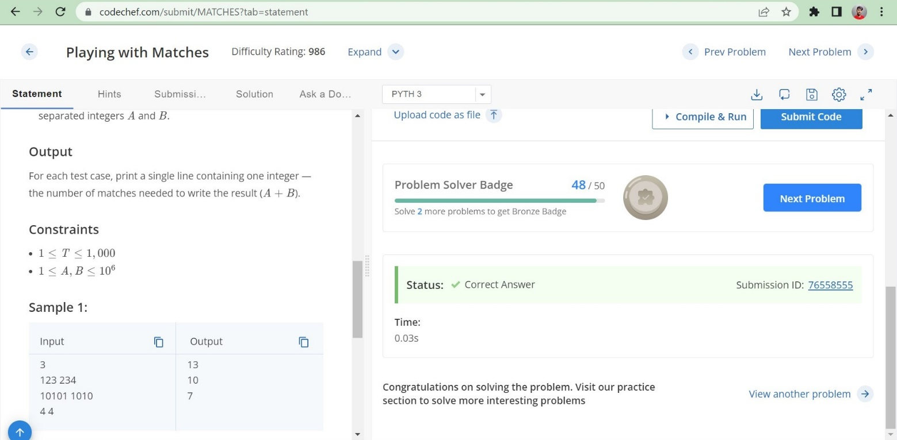

**Why only this DS is used?**

Counting no of sticks used to build that number using a list.

**Time Complexity :** O(n)

**Space Complexity :** O(n)

**Result :** Successfully Executed the Program.

**Task 2 :**

**Problem**

You are given a binary string A*A* of length N*N*.

You can perform the following type of operation on the string A*A*:

* Choose two **different** indices i*i* and j*j* (1\leq i,j\leq N)(1≤*i*,*j*≤*N*);
* Change A_i*Ai*​ and A_j*Aj*​ to A_i \oplus A_j*Ai*​⊕*Aj*​. Here \oplus⊕ represents the [bitwise XOR](https://en.wikipedia.org/wiki/Bitwise_operation#XOR) operation.

Find the **minimum** number of operations required to convert the given string into a [palindrome](https://en.wikipedia.org/wiki/Palindrome).

**Input Format**

* First line of the input contains T*T*, the number of test cases. Then the test cases follow.
* First line of each test case contains an integer N*N* denoting the size of the string.
* Second line of each test case contains a binary string A*A* of length N*N* containing 00s and 11s only.

**Output Format**

For each test case, print the **minimum** number of operations required to make the string a palindrome.

**Solution**

for _ in range(int(input())):

n = int(input())

a = input()

if n==1:

count = 0

else:

count = 0

for i in range(n//2):

if a[i]!=a[n-i-1]:

#xor = int(a[i]) ^ int(a[-i])

#a[i] = str(xor)

#a[-i] = str(xor)

#print("doesn't match",a[i],a[-i])

count = count+1

print((count+1)//2)

**Test Cases**

**Input:**

4

5

11011

7

0111010

1

1

4

1100

**Output :**

0

1

0

1

**Result**

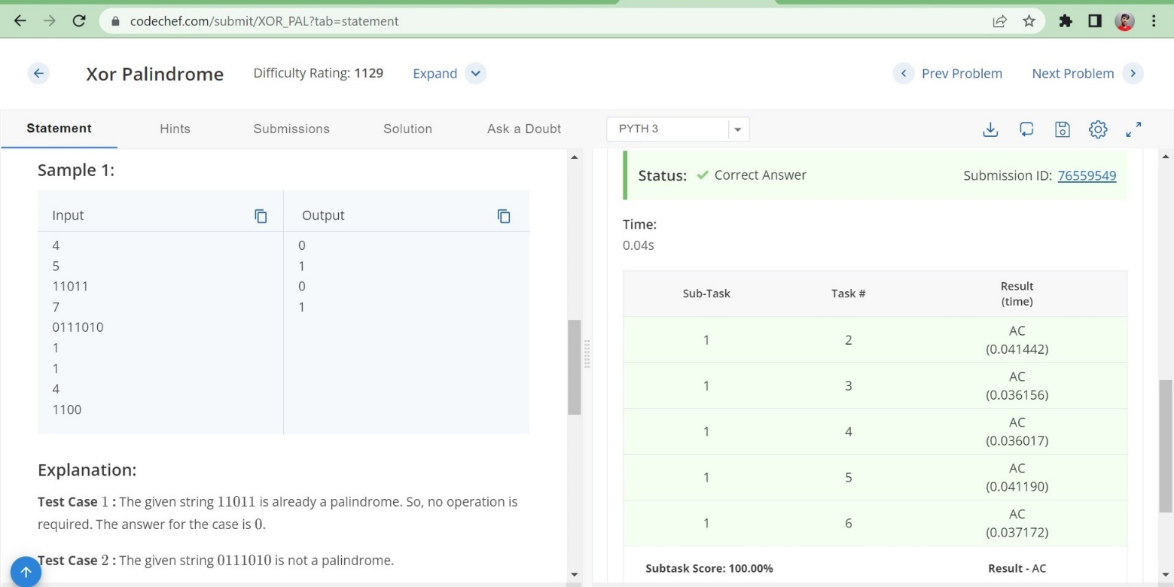

**Why only this DS is used?**

No special data structure is not used here only a simple logic which is counting no of elements which spoil palindrome and divide it by 2 by adding 1 to sum

**Time Complexity :** O(n)

**Space Complexity :** O(n)

**Result :** Successfully Executed the Program.

**Task 3 :**

**Problem**

Chef has N*N* small boxes arranged on a line from 11 to N*N*. For each valid i*i*, the weight of the i*i*-th box is W_i*Wi*​. Chef wants to bring them to his home, which is at the position 00. He can hold any number of boxes at the same time; however, the total weight of the boxes he's holding must not exceed K at any time, and he can only pick the ith box if all the boxes between Chef's home and the ith box have been either moved or picked up in this trip.

Therefore, Chef will pick up boxes and carry them home in one or more round trips. Find the smallest number of round trips he needs or determine that he cannot bring all boxes home.

**Input**

* The first line of the input contains a single integer T*T* denoting the number of test cases. The description of T*T* test cases follows.
* The first line of each test case contains two space-separated integers N*N* and K*K*.
* The second line contains N*N* space-separated integers W_1, W_2, \ldots, W_N*W*1​,*W*2​,…,*WN*​.

**Output**

For each test case, print a single line containing one integer ― the smallest number of round trips or -1−1 if it is impossible for Chef to bring all boxes home.

**Solution**

**# cook your dish here**

for _ in range(int(input())):

n,k=map(int,input().split())

l=list(map(int,input().split()))[:n]

if max(l)>k:

print("-1")

else:

count = 0

s = 0

for i in range(n) :

if s+l[i]<=k:

s+=l[i]

else:

s=l[i]

count+=1

print(count+1)

**Test Cases**

**Input:**

4

1 1

2

2 4

1 1

3 6

3 4 2

3 6

3 4 3

**Output :**

-1

1

2

3

**Result**

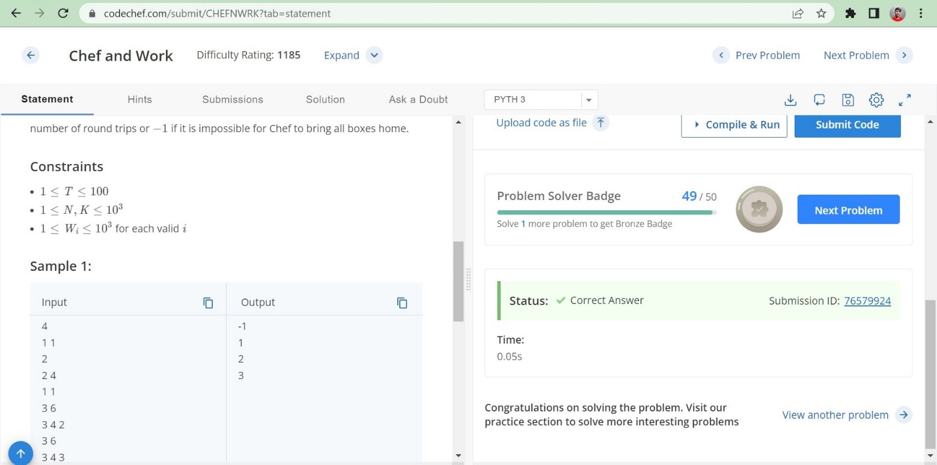

**Why only this DS is used?**

No data structure as such we are just using a list to input values and applying logic on it with a for loop

**Time Complexity :** O(n)

**Space Complexity :** O(n)

**Result :** Successfully Executed the Program.

**WEEK – 5**

**Task 1**

**Problem**

On a sunny day, Akbar and Birbal were taking a leisurely walk in palace gardens. Suddenly, Akbar noticed a bunch of sticks on the ground and decided to test Birbal's wits.

There are N*N* stick holders with negligible size (numbered 11 through N*N*) in a row on the ground. Akbar places all the sticks in them vertically; for each valid i*i*, the initial height of the stick in the i*i*-th holder is A_i*Ai*​. Birbal has a stick cutter and his task is to completely cut all these sticks, i.e. reduce the heights of all sticks to 00. He may perform zero or more operations; in each operation, he should do the following:

* Choose an integer H*H* and fix the cutter at the height H*H* above the ground.
* The cutter moves from the 11-st to the N*N*-th stick holder. Whenever it encounters a stick whose current height is greater than H*H*, it cuts this stick down to height H*H* (i.e. for a stick with height h \gt H*h*>*H*, it removes its upper part with length h-H*h*−*H*).
* All the upper parts of sticks that are cut in one operation must have equal lengths. Otherwise, the operation may not be performed.

For example, if the heights of sticks are initially [5, 3, 5][5,3,5], then some valid values for H*H* in the first operation are 33 and 44 ― the cutter cuts the upper parts of two sticks and their lengths are [2, 2][2,2] and [1, 1][1,1] respectively. H = 2*H*=2 is an invalid choice because it would cut the upper parts of all three sticks with lengths [3, 1, 3][3,1,3], which are not all equal.

Akbar wants Birbal to completely cut all sticks in the minimum possible number of operations. If you want to be friends with Birbal, help him solve the problem.

**Input**

* The first line of the input contains a single integer T*T* denoting the number of test cases. The description of T*T* test cases follows.
* The first line of each test case contains a single integer N*N*.
* The second line contains N*N* space-separated integers A_1, A_2, \ldots, A_N*A*1​,*A*2​,…,*AN*​.

**Output**

For each test case, print a single line containing one integer ― the minimum number of operations needed to completely cut all the sticks.

**Solution:**

t = int(input())

for i in range(t):

n = int(input())

l = list(map(int, input().split()))

l = list(set(l))

x = l.count(0)

print(len(l) - x)

**Test Cases**

**Input:**

1

3

1 2 3

**Output:**

3

**Result:**

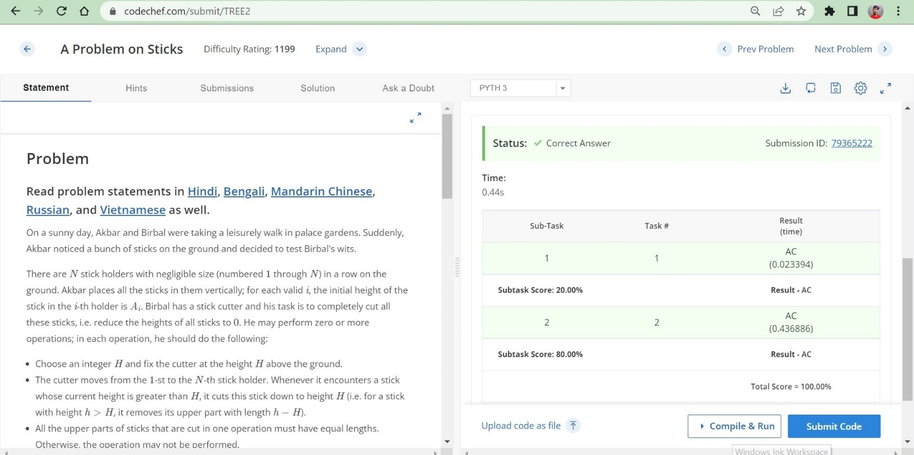

**Why only this DS is used?**

No special data structure is not used here only a simple logic by using a for loop

**Time Complexity :** O(n)

**Space Complexity :** O(n)

**Result :** Successfully Executed the Program.

**Task 2**

**Problem**

Chef is very hungry. So, Chef goes to a shop selling burgers. The shop has 22 types of burgers:

Normal burgers, which cost XX rupees each

Premium burgers, which cost YY rupees each (where Y \gt XY>X)

Chef has RR rupees. Chef wants to buy exactly NN burgers. He also wants to maximize the number of premium burgers he buys. Determine the number of burgers of both types Chef must buy.

Output -1−1 if it is not possible for Chef to buy NN burgers.

**Input Format**

The first line contains a single integer TT — the number of test cases. Then the test cases follow.

The first and only line of each test case contains four space-separated integers XX, YY, NN and RR — the cost of a normal burger, the cost of a premium burger, the number of burgers Chef wants to buy and the amount of money Chef has.

**Output Format**

For each test case, output on a new line two integers: the number of normal burgers and the number of premium burgers Chef must buy satisfying the given conditions.

Output -1−1 if he cannot buy NN burgers.

**Solution**

t = int(input())

for _ in range(t):

x,y,n,r = map(int,input().split())

if y*n <= r:

print(0,n)

elif x*n > r:

print(-1)

else:

z = (r - (n*x)) // (y-x)

print((n - z), z)

**Test Cases**

**Input:**

4

2 10 4 12

4 8 10 50

99 100 5 10

9 10 10 200

**Output:**

4 0

8 2

-1

0 10

**Result :**

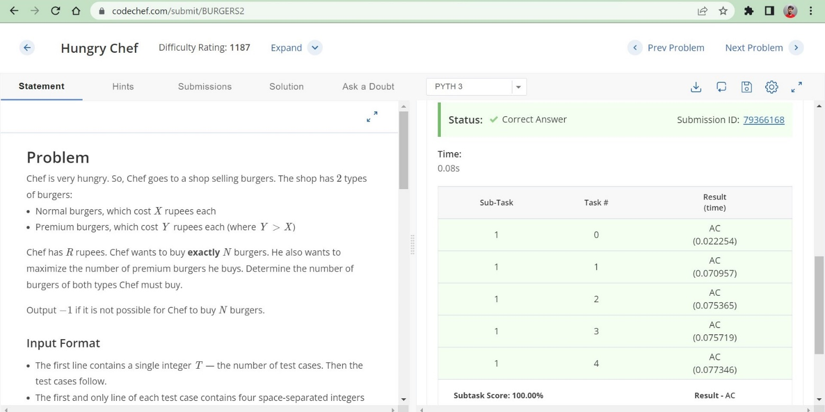

**Why only this DS is used?**

No special data structure is not used here only a simple logic by using a for loop and some conditional statements.

**Time Complexity :** O(n)

**Space Complexity :** O(n)

**Result :** Successfully Executed the Program.

**Task 3**

**Problem**

Chef is given a binary string A*A* of length N*N*. He can perform the following operation on A*A* any number of times:

* Choose L*L* and R*R* (1 \leq L \leq R \leq N)(1≤*L*≤*R*≤*N*), such that, in the [substring](https://en.wikipedia.org/wiki/Substring) A[L,R]*A*[*L*,*R*], the number of 11s is **equal** to the number of 00s and **reverse** the substring A[L,R]*A*[*L*,*R*].

Find the lexicographically **smallest** string that Chef can obtain after performing the above operation **any** (possibly zero) number of times on A*A*.

String X*X* is lexicographically smaller than string Y*Y*, if either of the following satisfies:

* X*X* is a prefix of Y*Y* and X \neq Y*X*=*Y*.
* There exists an index i*i* such that X_i \lt Y_i*Xi*​<*Yi*​ and X_j = Y_j, \forall j*Xj*​=*Yj*​,∀*j* such that 1 \leq j \lt i1≤*j*<*i*.

**Input Format**

* First line will contain T*T*, the number of test cases. Then the test cases follow. Each test case contains two lines.
* The first line contains the integer N*N*, the length of the binary string.
* The second line contains the binary string A*A*.

**Output Format**

For each test case, print the lexicographically **smallest** binary string that can be obtained after performing the operation **any** (possibly zero) number of times.

**Solution:**

n=int(input ())

for i in range(n):

t=int(input ())

a=input ()

x=a.count('0')

y=a.count('1')

print (x*'0'+y*'1')

**Test Cases**

**Input:**

2

5

01100

4

0000

**Output:**

00011

0000

**Result:**

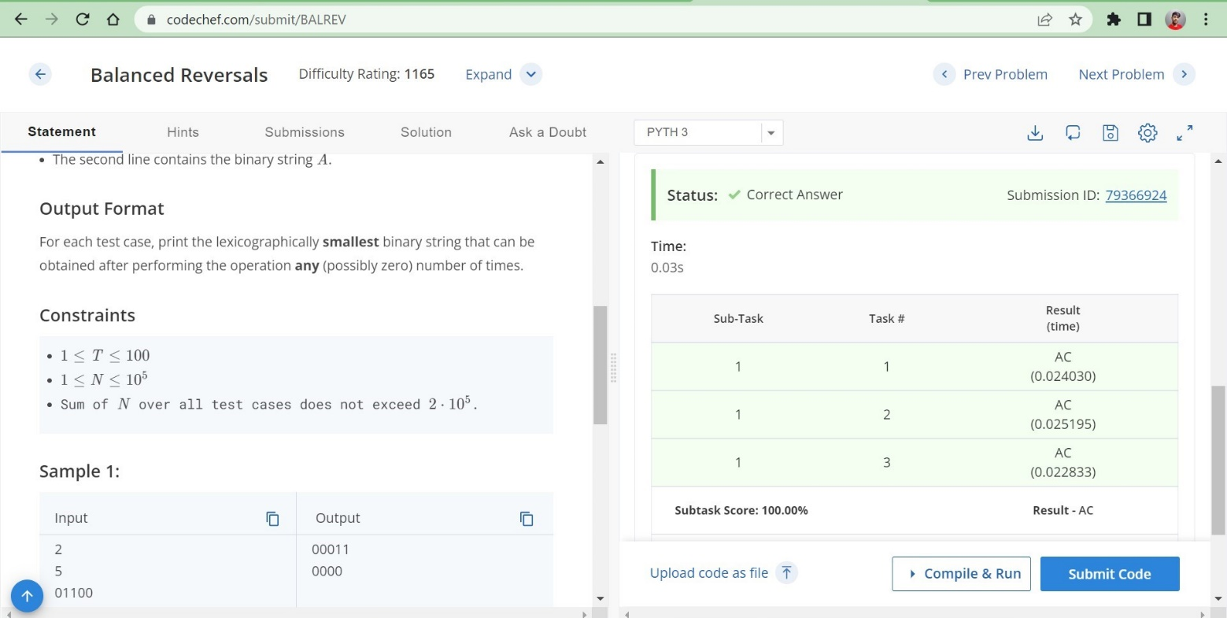

**Why only this DS is used?**

No special data structure is not used here only a simple logic by using a for loop and some conditional statements and mathematical expressions.

**Time Complexity :** O(n)

**Space Complexity :** O(n)

**Result :** Successfully Executed the Program.

**WEEK – 6**

**Task 1**

**Problem**

The annual snake festival is upon us, and all the snakes of the kingdom have gathered to participate in the procession. Chef has been tasked with reporting on the procession, and for this he decides to first keep track of all the snakes. When he sees a snake first, it'll be its Head, and hence he will mark a 'H'. The snakes are long, and when he sees the snake finally slither away, he'll mark a 'T' to denote its tail. In the time in between, when the snake is moving past him, or the time between one snake and the next snake, he marks with '.'s.

Because the snakes come in a procession, and one by one, a valid report would be something like "..H..T...HTH....T.", or "...", or "HT", whereas "T...H..H.T", "H..T..H", "H..H..T..T" would be invalid reports (See explanations at the bottom).

Formally, a snake is represented by a 'H' followed by some (possibly zero) '.'s, and then a 'T'. A valid report is one such that it begins with a (possibly zero length) string of '.'s, and then some (possibly zero) snakes between which there can be some '.'s, and then finally ends with some (possibly zero) '.'s.

Chef had binged on the festival food and had been very drowsy. So his report might be invalid. You need to help him find out if his report is valid or not.

**Input**

* The first line contains a single integer, R*R*, which denotes the number of reports to be checked. The description of each report follows after this.
* The first line of each report contains a single integer, L*L*, the length of that report.
* The second line of each report contains a string of length L*L*. The string contains only the characters '.', 'H', and 'T'.

**Output**

* For each report, output the string **Valid** or **Invalid** in a new line, depending on whether it was a valid report or not.

**Solution:**

for _ in range(int(input())):

n=int(input())

l=input()

l=l.replace(".","")

l=l.replace("HT","")

if(len(l)):

print("Invalid")

else:

print("Valid")

**Test Cases**

**Input:**

6

18

..H..T...HTH....T.

3

...

10

H..H..T..T

2

HT

11

.T...H..H.T

7

H..T..H

**Output:**

Valid

Valid

Invalid

Valid

Invalid

Invalid

**Result:**

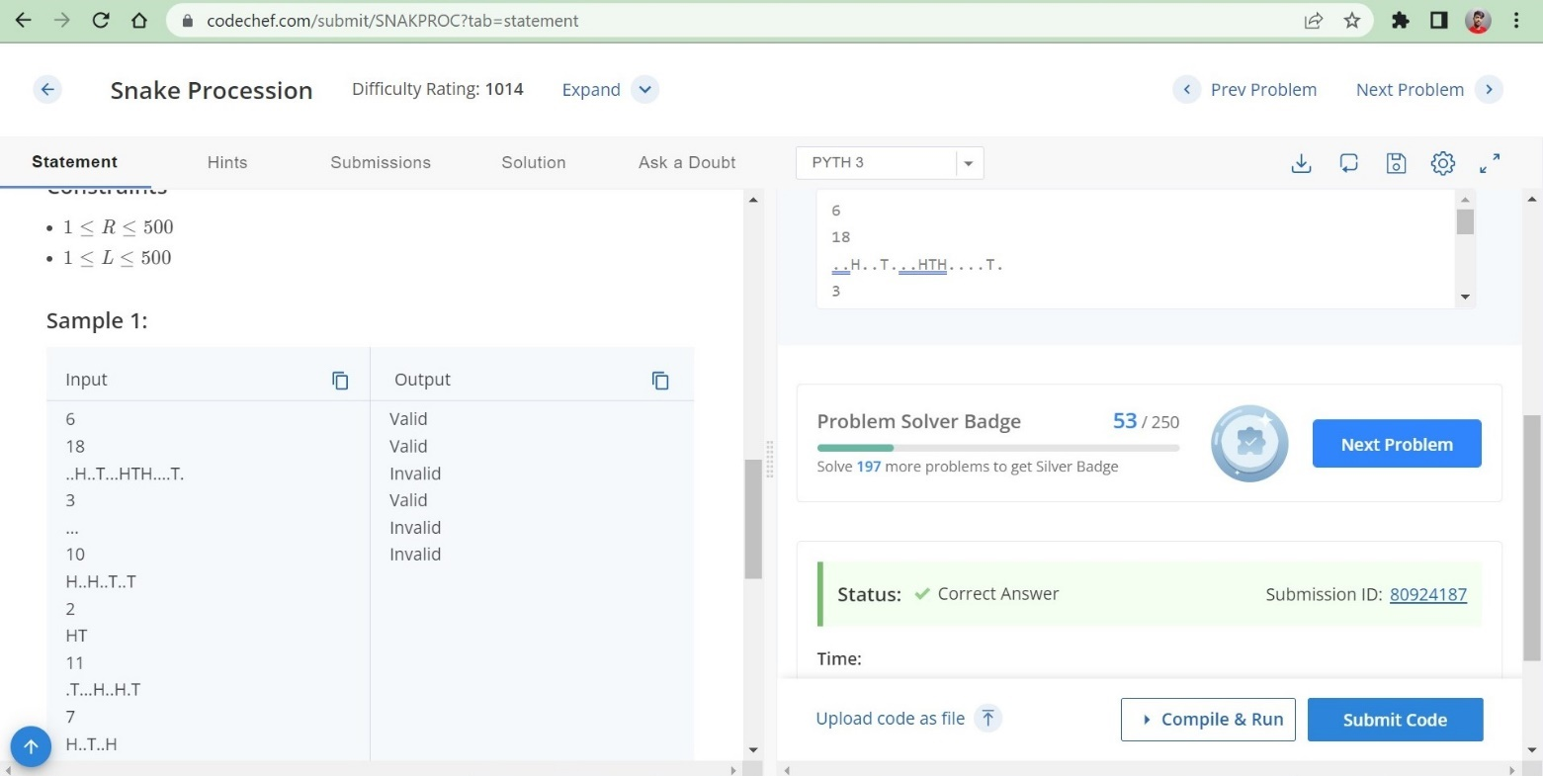

**Why only this DS is used?**

No special data structure is not used here only a simple logic by using some conditional statements and mathematical expressions.

**Time Complexity :** O(n)

**Space Complexity :** O(n)

**Result :** Successfully Executed the Program.

**Task 2**

## **Problem**

The chef has a recipe he wishes to use for his guests, but the recipe will make far more food than he can serve to the guests. The chef therefore would like to make a reduced version of the recipe which has the same ratios of ingredients, but makes less food. The chef, however, does not like fractions. The original recipe contains only whole numbers of ingredients, and the chef wants the reduced recipe to only contain whole numbers of ingredients as well. Help the chef determine how much of each ingredient to use in order to make as little food as possible.

### Input

Input will begin with an integer T, the number of test cases. Each test case consists of a single line. The line begins with a positive integer N, the number of ingredients. N integers follow, each indicating the quantity of a particular ingredient that is used.

### Output

For each test case, output exactly N space-separated integers on a line, giving the quantity of each ingredient that the chef should use in order to make as little food as possible.

**Test Cases**

**Input:**

3

2 4 4

3 2 3 4

4 3 15 9 6

**Output:**

1 1

2 3 4

1 5 3 2

**Result:**

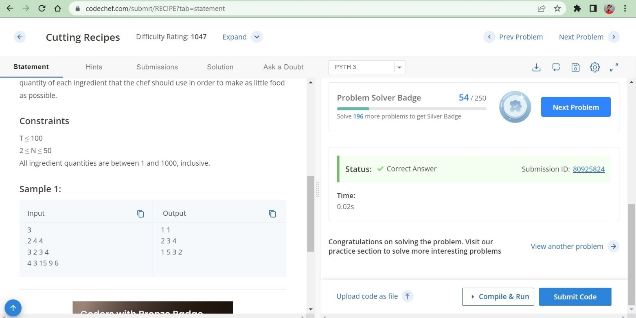

**Why only this DS is used?**

No special data structure is not used math module and list data structure is used .

**Time Complexity :** O(n)

**Space Complexity :** O(n)

**Result :** Successfully Executed the Program.

**Task 3**

**Problem**

You are given a binary string S*S* of length N*N*. You can perform the following operation on S*S*:

* Pick any set of indices such that no two picked indices are adjacent.
* Flip the values at the picked indices (i.e. change 00 to 11 and 11 to 00).

For example, consider the string S = 1101101*S*=1101101.  
If we pick the indices \{1,3,6\}{1,3,6}, then after flipping the values at picked indices, we will get \underline{1}1\underline{0}11\underline{0}1 \rightarrow 01111111​10​110​1→0111111.  
Note that we cannot pick the set \{2,3,5\}{2,3,5} since 22 and 33 are adjacent indices.

Find the **minimum** number of operations required to convert **all** the characters of S*S* to 00.

**Input Format**

* The first line contains a single integer T*T* - the number of test cases. Then the test cases follow.
* The first line of each test case contains an integer N*N* - the length of the binary string S*S*.
* The second line of each test case contains a binary string S*S* of length N*N*.

**Output Format**

For each test case, output the **minimum** number of operations required to convert all the characters of S*S* to 00.

**Solution:**

n=int(input())

for i in range(n):

s=int(input())

d=input()

if '1'in d and'11' not in d:

print(1)

elif '11' in d:

print(2)

else:

print(0)

**Test Cases**

**Input:**

3

6

101001

5

00000

3

111

**Output:**

1

0

2

**Result:**

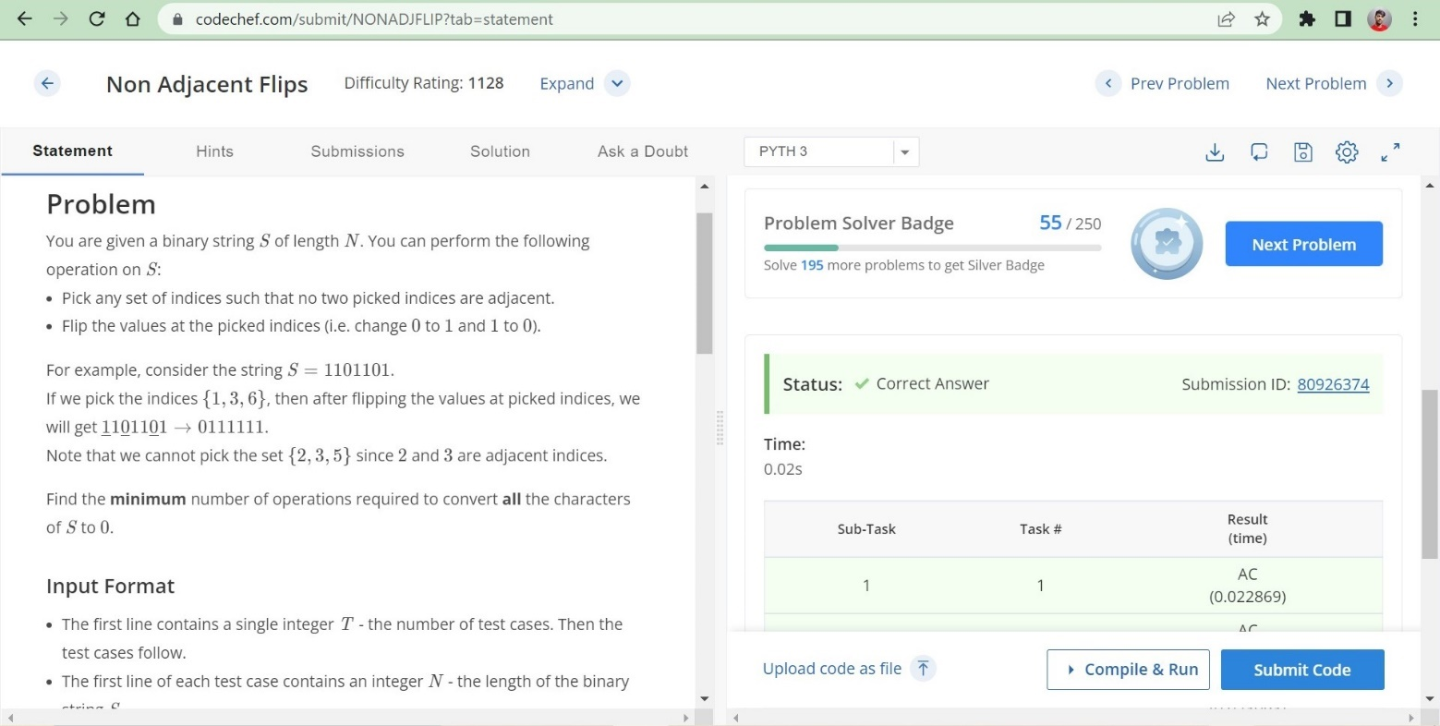

**Why only this DS is used?**

No special data structure is not used simple conditional statements are used.

**Time Complexity :** O(n)

**Space Complexity :** O(n)

**Result :** Successfully Executed the Program.

**WEEK – 7**

**Task 1**

## **Problem**

Chef has a string S*S* consisting of lowercase English characters. Chef defined functions left shift L(X)*L*(*X*) and right shift R(X)*R*(*X*) as follows.

* L(X)*L*(*X*) is defined as shifting all characters of string X*X* one step towards left and moving the first character to the end.
* R(X)*R*(*X*) is defined as shifting all characters of string X*X* one step towards the right and moving the last character to the beginning.

For example, L("abcd") = "bcda" and R("abcd") = "dabc"

Chef wants to find out whether there exists a string V*V* of the same length as S*S* such that both L(V) = S*L*(*V*)=*S* and R(V) = S*R*(*V*)=*S* holds.

**Input:**

* The first line of the input contains a single integer T*T* denoting the number of test cases. The description of T*T* test cases follows.
* The first line of each test case contains a string S*S*.

**Output:**

For each test case, If there exists a valid string V*V*, print "YES", otherwise print "NO" (without the quotes).

**Solution:**

for _ in range(int(input())):

s=input()

a=s[1:]+s[0]

b=s[-1]+s[:-1]

if a==b:

print("YES")

else:

print("NO")

**Test Cases**

**Input:**

4

a

ab

abcd

aaaaa

**Output:**

YES

YES

NO

YES

**Result:**

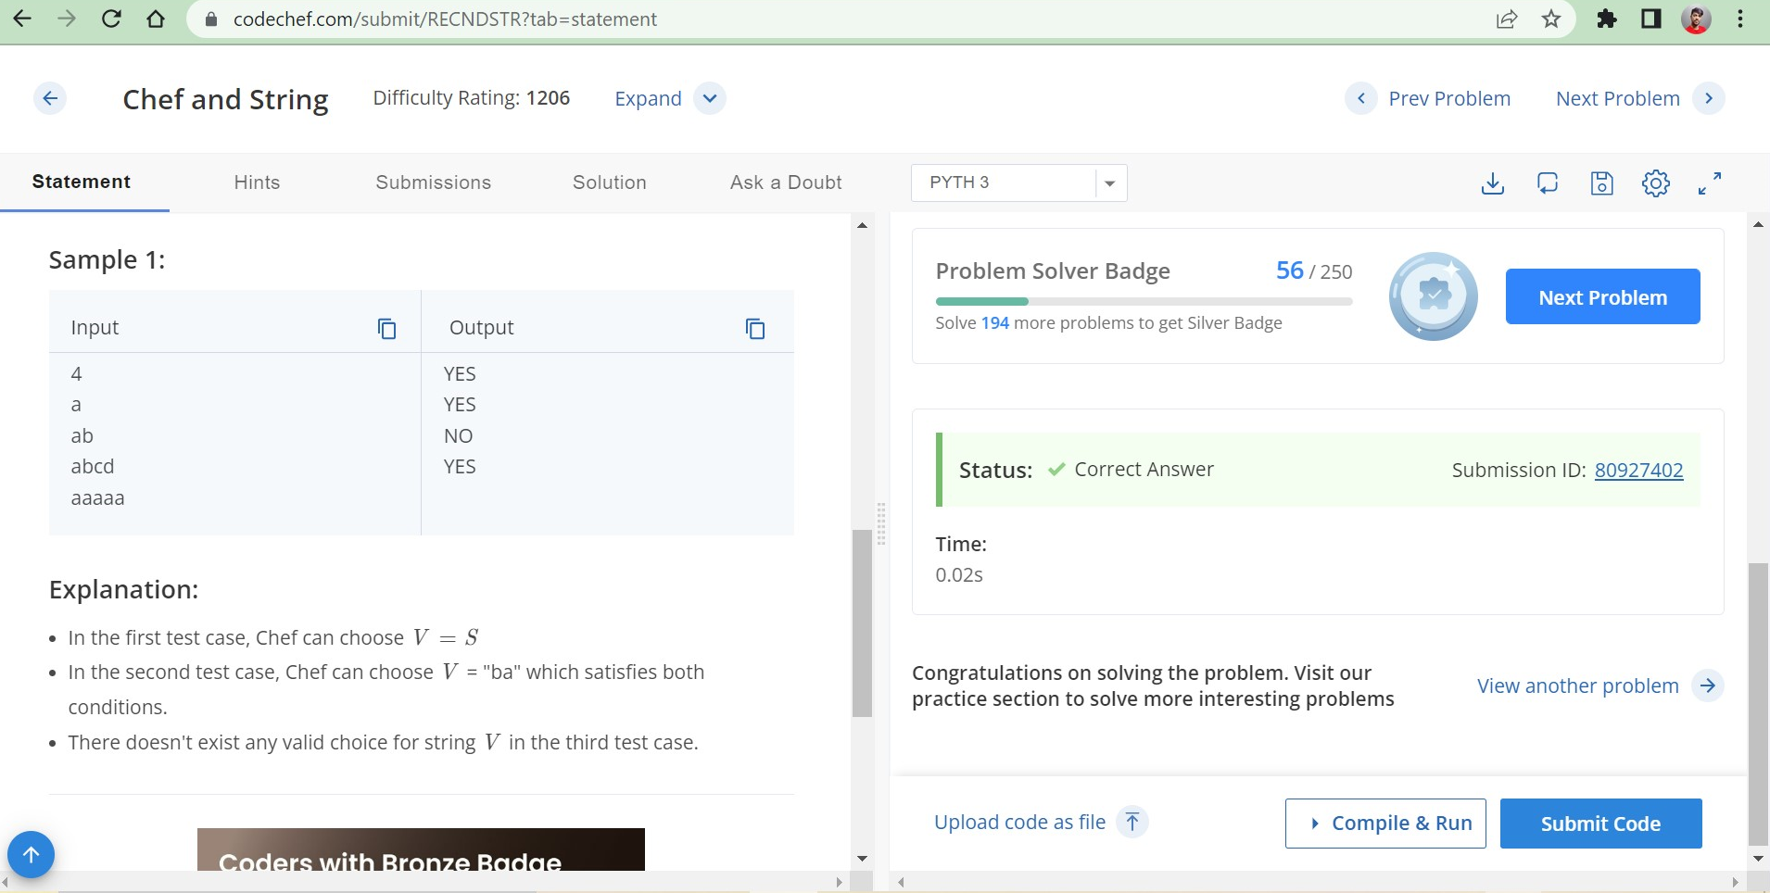

**Why only this DS is used?**

Simple list slicing operations are done to solve this problem.

**Time Complexity :** O(n)

**Space Complexity :** O(n)

**Result :** Successfully Executed the Program.

**Task 2**

## **Problem**

Pushpa has entered Chefland and wants to establish Pushpa-Raj here too.

Chefland has N*N* towers where the height of the i^{th}*ith* tower is H_i*Hi*​. To establish Pushpa-Raj, Pushpa does the following:

* Initially, Pushpa chooses any tower i*i* (1\le i \le N)(1≤*i*≤*N*) and lands on the roof of that tower.
* Let X*X* denote the height of the tower Pushpa is currently on, then, Pushpa can land on the roof of any tower j*j* (1\le j \le N)(1≤*j*≤*N*) such that the height of the j^{th}*jth* tower is (X+1)(*X*+1).

Let i*i* denote the index of the tower on which Pushpa lands, then, the height of all towers **except** tower i*i* **increases** by 11 after each jump **including the initial jump**.

To establish Pushpa-Raj, Pushpa wants to land at the **maximum** height possible. Determine the maximum height Pushpa can reach.

**Input Format**

* The first line contains a single integer T*T* - the number of test cases. Then the test cases follow.
* The first line of each test case contains an integer N*N* - the number of towers
* The second line of each test case contains N*N* space-separated integers H_1, H_2, \dots, H_N*H*1​,*H*2​,…,*HN*​ denoting the initial heights of each of the towers from the ground.

**Output Format**

For each test case, output in a single line the **maximum** height achieved by Pushpa.

**Solution:**

from collections import Counter

for _ in range(int(input())):

n = int(input())

h = list(map(int, input().split()))

c = Counter(h)

best=[k+v-1 for k,v in c.items()]

print(max(max(best),max(h)))

**Test Cases**

**Input:**

2

4

1 2 1 3

1

2

**Output:**

3

2

**Result:**

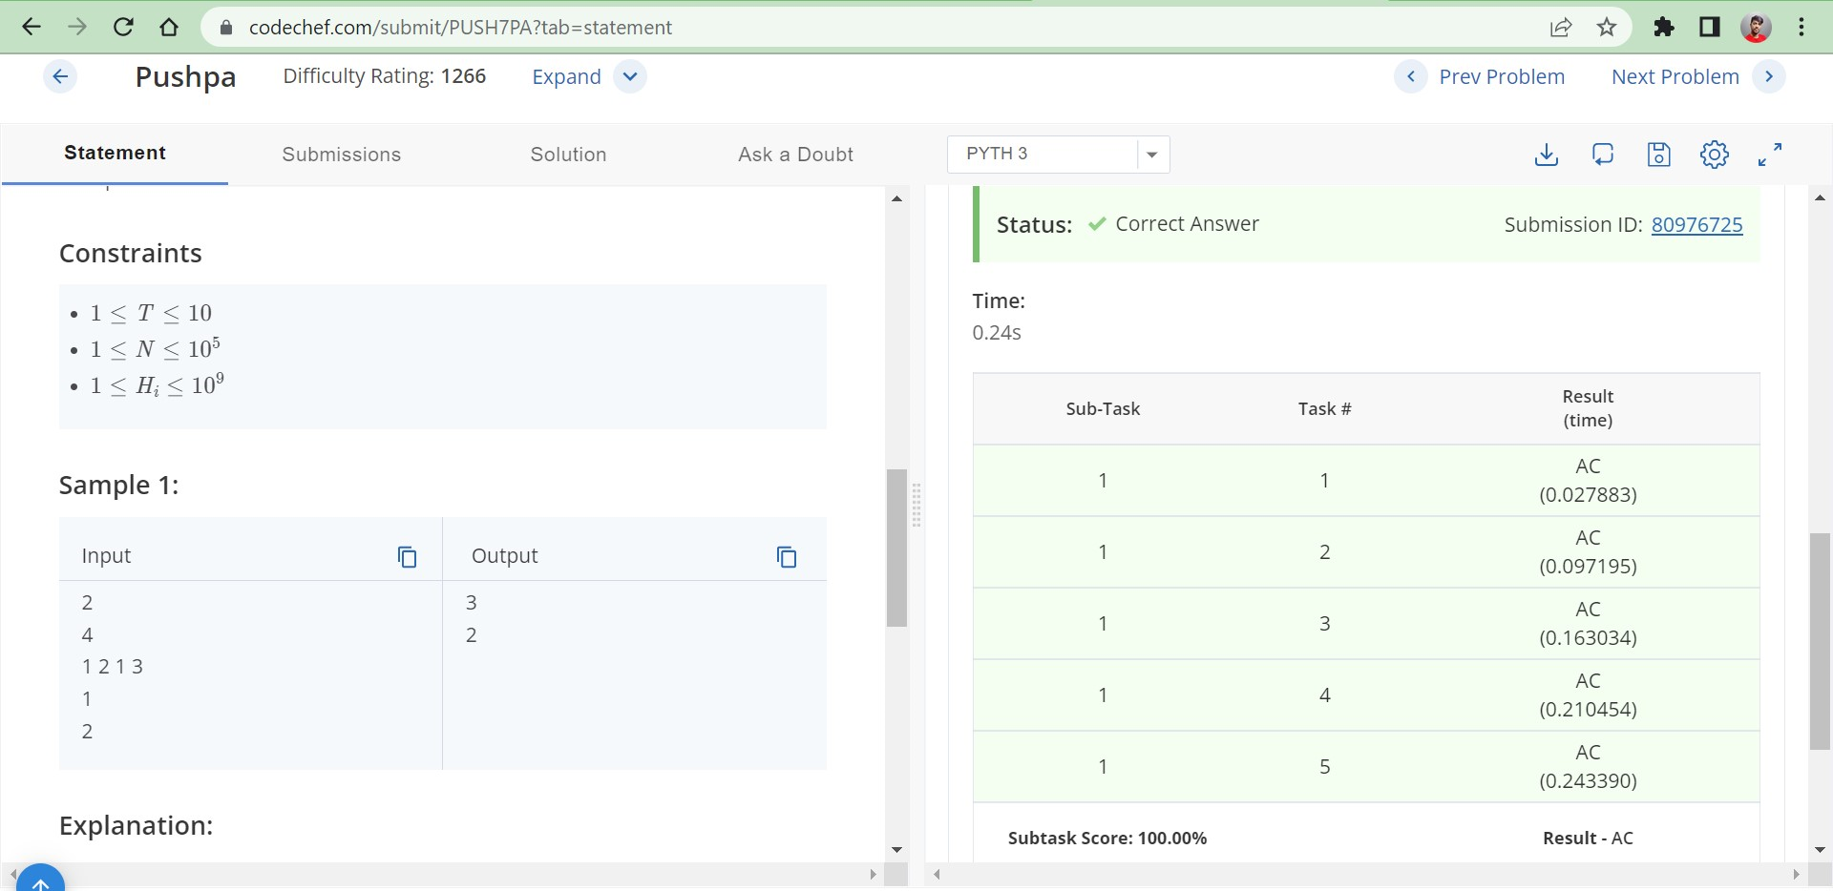

**Why only this DS is used?**

Here different permutations are compared using collections module

**Time Complexity :** O(n)

**Space Complexity :** O(n)

**Result :** Successfully Executed the Program.

**Task 3**

## **Problem**

Chef recently solved his first problem on CodeChef. The problem he solved has N*N* test cases. He gets a score for his submission according to the following rules:

1. If Chef’s code passes all the N*N* test cases, he gets 100100 points.
2. If Chef’s code does not pass all the test cases, but passes all the **first** M\;(M \lt N)*M*(*M*<*N*) test cases, he gets K\;(K \lt 100)*K*(*K*<100) points.
3. If the conditions 11 and 22 are not satisfied, Chef does not get any points (i.e his score remains at 00 points).

You are given a binary array A_1, A_2, \dots, A_N*A*1​,*A*2​,…,*AN*​ of length N*N*, where A_i = 1*Ai*​=1 denotes Chef's code passed the i^{th}*ith* test case, A_i = 0*Ai*​=0 denotes otherwise. You are also given the two integers M, K*M*,*K*. Can you find how many points does Chef get?

**Input Format**

* First line will contain T*T*, number of testcases. Then the testcases follow.
* The first line of each test case contains three space-separated integers N, M, K*N*,*M*,*K*.
* The second line contains N*N* space-separated integer A_1, A_2,\dots, A_N*A*1​,*A*2​,…,*AN*​.

**Output Format**

For each testcase, output in a single line the score of Chef.

Solution:

t=int(input())

for _ in range(t):

n,m,k=list(map(int,input().split()))

a=list(map(str,input().split()))

lis=[]

for i in range(m):

lis.append(a[i])

if a.count('1')==len(a):

print(100)

elif lis.count('1')==len(lis):

print(k)

else:

print(0)

**Test Cases**

**Input:**

4

4 2 50

1 0 1 1

3 2 50

1 1 0

4 2 50

1 1 1 1

5 3 30

1 1 0 1 1

**Output:**

0

50

100

0

**Result:**

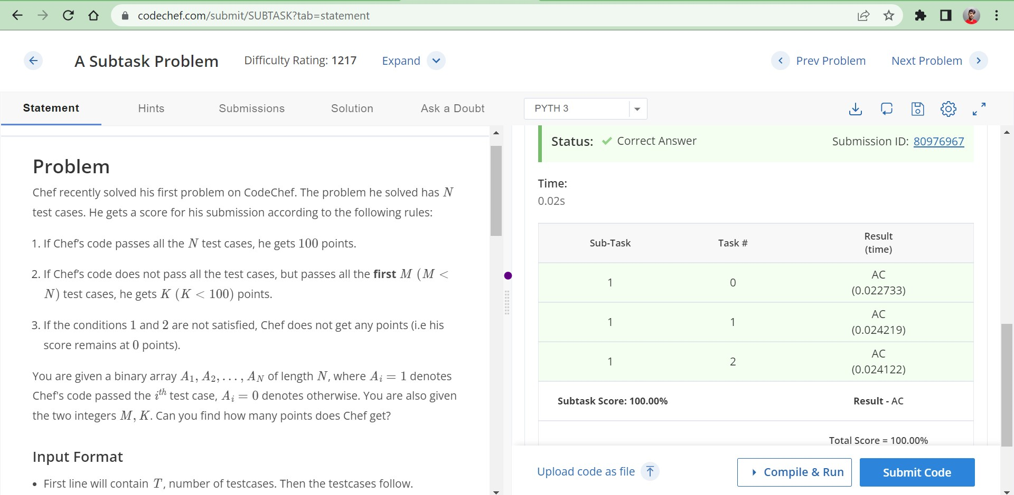

**Why only this DS is used?**

Simple List operations are used to solve this problem.

**Time Complexity :** O(n^2)

**Space Complexity :** O(n^2)

**Result :** Successfully Executed the Program.

**WEEK – 8**

**Task 1**

## **Problem**

Given a valid (IPv4) IP address, return a defanged version of that IP address.

A *defanged IP address* replaces every period "." with "[.]".

**Example 1:**

**Input:** address = "1.1.1.1"

**Output:** "1[.]1[.]1[.]1"

**Example 2:**

**Input:** address = "255.100.50.0"

**Output:** "255[.]100[.]50[.]0"

Code:

class Solution:

    def defangIPaddr(self, address: str) -> str:

        return address.replace(".","[.]")

**Test Cases**

**Input:**

1.1.1.1

255.100.50.0

Output:

1[.]1[.]1[.]1

255[.]100[.]50[.]0

**Result:**

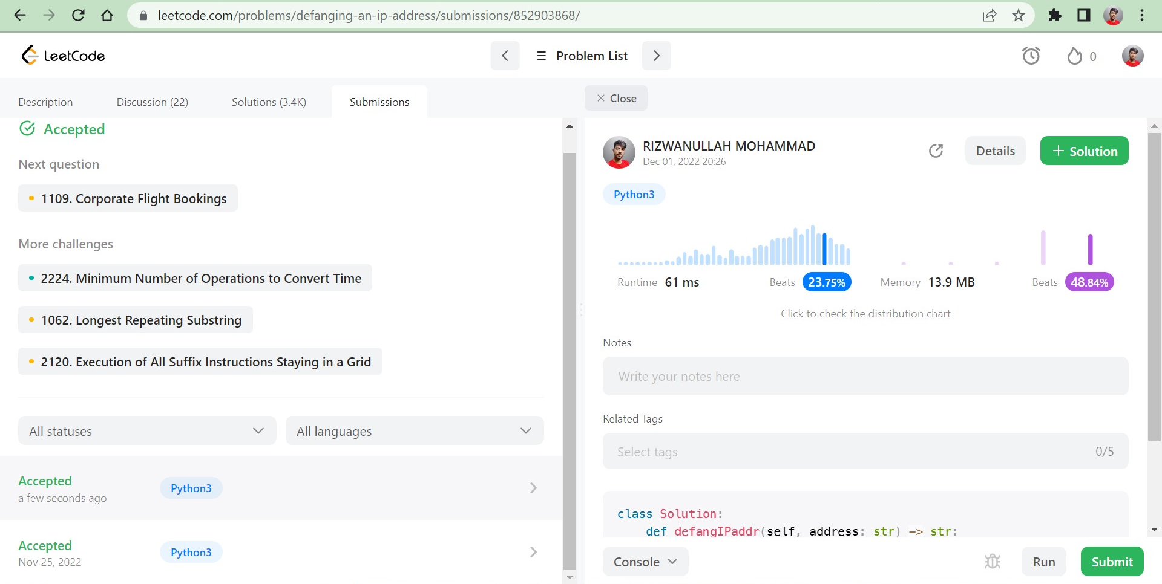

**Time Complexity :** O(1)

**Space Complexity :** O(1)

**Result :** Successfully Executed the Program

**Task 2**

## **Problem**

Given a **zero-based permutation** nums (**0-indexed**), build an array ans of the **same length** where ans[i] = nums[nums[i]] for each 0 <= i < nums.length and return it.

A **zero-based permutation** nums is an array of **distinct** integers from 0 to nums.length - 1 (**inclusive**).

**Example 1:**

**Input:** nums = [0,2,1,5,3,4]

**Output:** [0,1,2,4,5,3]

**Example 2:**

**Input:** nums = [5,0,1,2,3,4]

**Output:** [4,5,0,1,2,3]

Code:

class Solution:

    def buildArray(self, nums: List[int]) -> List[int]:

        arr = []

        for i in range(len(nums)):

            arr.append(nums[nums[i]])

        return arr

**Result:**

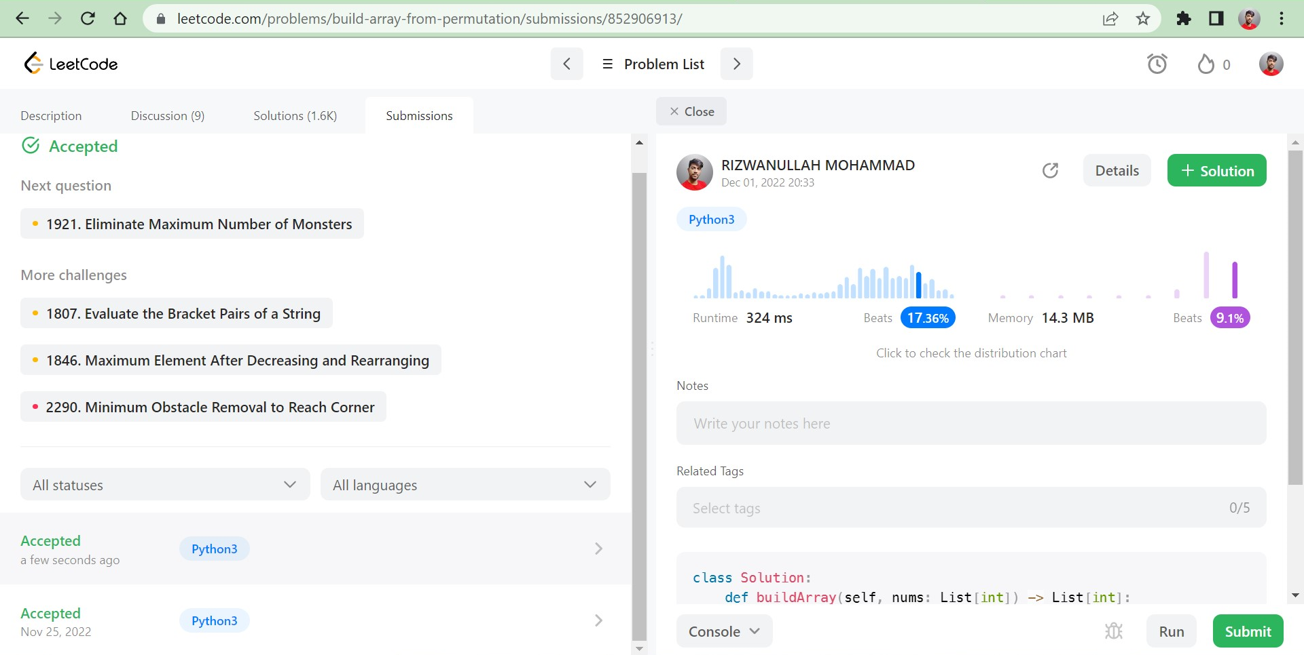

**Test Cases**

**Input:**

[0,2,1,5,3,4]

[5,0,1,2,3,4]

**Output:**

[0,1,2,4,5,3]

[4,5,0,1,2,3]

**Time Complexity :** O(n)

**Space Complexity :** O(n)

**Result :** Successfully Executed the Program.

**WEEK – 9**

**Task 1**

## **Problem**

Given the head of a singly linked list, reverse the list, and return *the reversed list*.

**Example 2:**

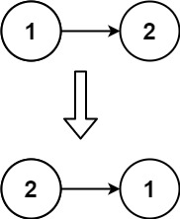

**Input:** head = [1,2]

**Output:** [2,1]

Code:

# Definition for singly-linked list.

# class ListNode:

#     def __init__(self, val=0, next=None):

#         self.val = val

#         self.next = next

class Solution:

    def reverseList(self, head: Optional[ListNode]) -> Optional[ListNode]:

        if head == None:

            return None

        elif head != None and head.next == None:

            return head

        else:

            temp = None

            next_node = None

            while head != None:

                next_node = head.next

                head.next = temp

                temp = head

                head = next_node

            return temp

**Result:**

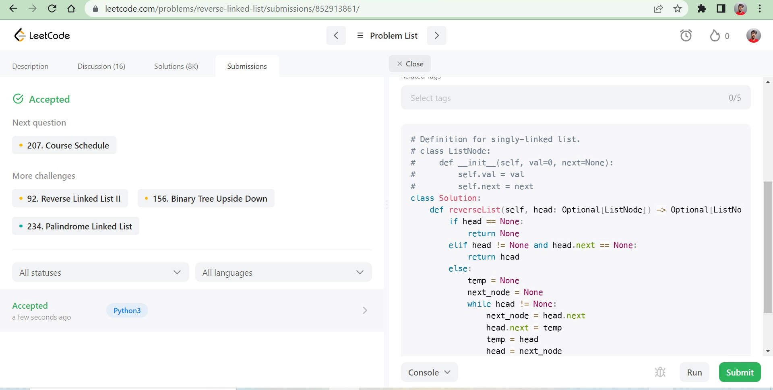

**Time Complexity :** O(n)

**Space Complexity :** O(n)

**Result :** Successfully Executed the Program.

**Task 2**

## **Problem**

There are n seats and n students in a room. You are given an array seats of length n, where seats[i] is the position of the ith seat. You are also given the array students of length n, where students[j] is the position of the jth student.

You may perform the following move any number of times:

* Increase or decrease the position of the ith student by 1 (i.e., moving the ith student from position x to x + 1 or x - 1)

Return *the****minimum number of moves****required to move each student to a seat such that no two students are in the same seat.*

Note that there may be **multiple** seats or students in the **same**position at the beginning.

**Example 1:**

**Input:** seats = [3,1,5], students = [2,7,4]

**Output:** 4

Code:

class Solution:

    def minMovesToSeat(self, seats, students):

        ans=0

        seats.sort()

        students.sort()

        for i in range(len(seats)):

            ans=ans+abs(seats[i]-students[i])

        return ans

**Output:**

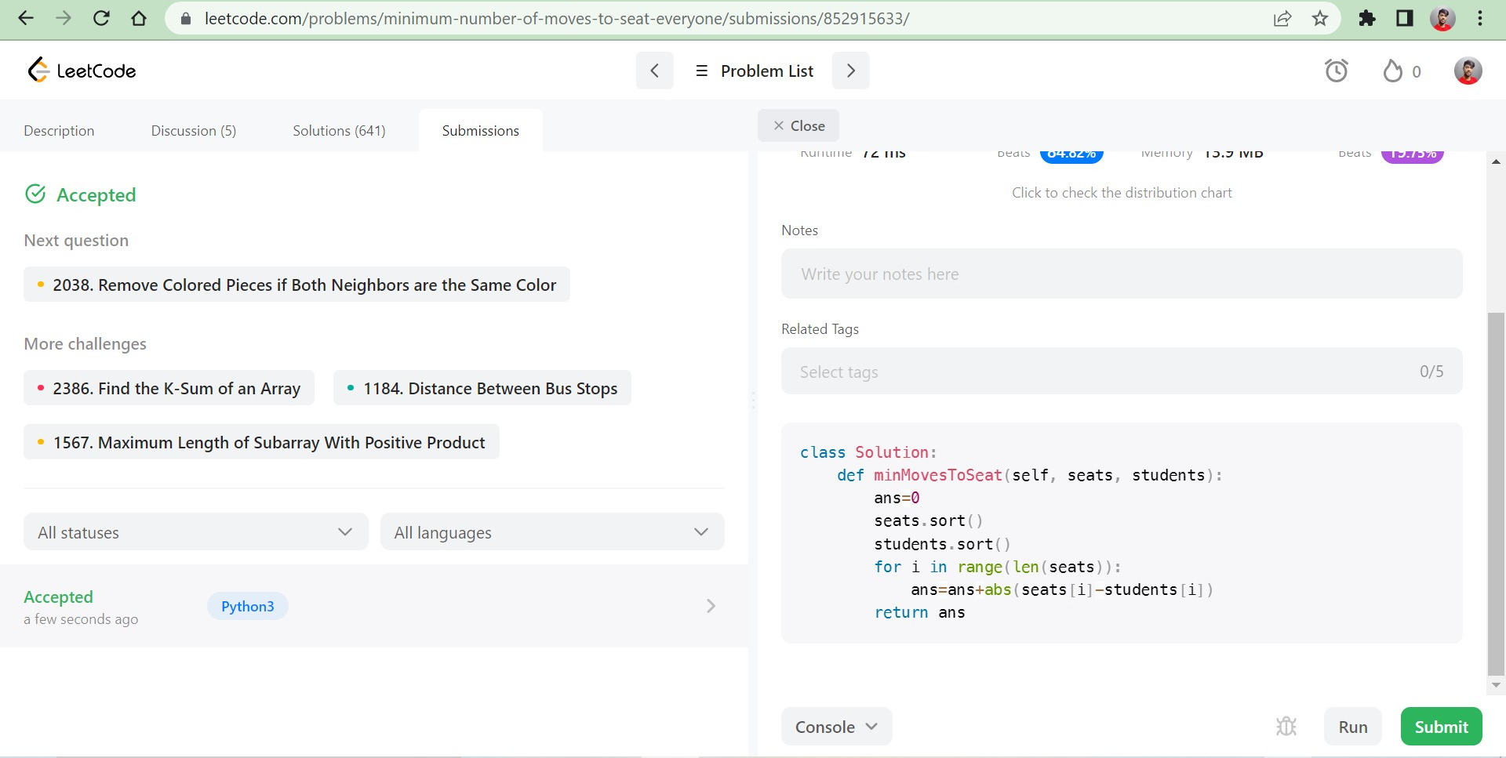

**Time Complexity :** O(n)

**Space Complexity :** O(n)

**Result :** Successfully Executed the Program.

**WEEK – 10**

**Task 1**

## **Problem**

Given an integer num, return *the number of steps to reduce it to zero*.

In one step, if the current number is even, you have to divide it by 2, otherwise, you have to subtract 1 from it.

**Example 1:**

**Input:** num = 14

**Output:** 6

**Example 2:**

**Input:** num = 8

**Output:** 4

Code:

class Solution:

    def numberOfSteps(self, num: int) -> int:

        c=0

        while(num!=0):

            if(num%2==0):

                c+=1

                num=num//2

            else:

                c+=1

                num=num-1

        return c

**Output:**

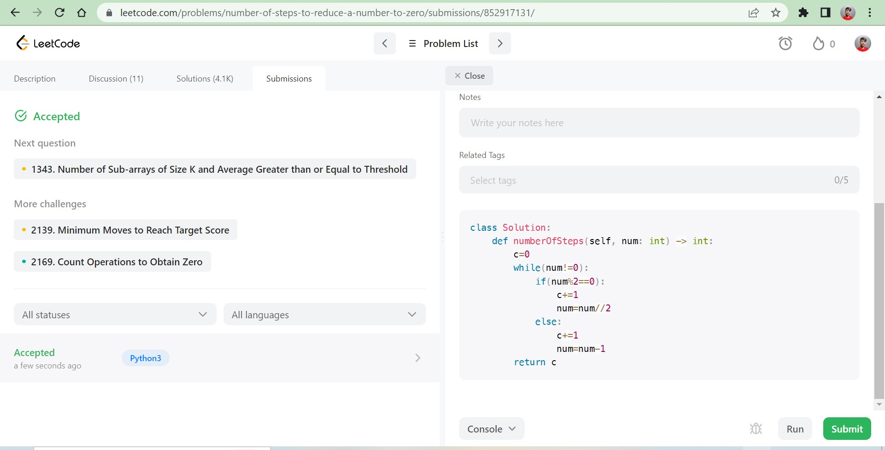

**Time Complexity :** O(n)

**Space Complexity :** O(n)

**Result :** Successfully Executed the Program

**Task 2**

## **Problem**

Given two integers num1 and num2, return *the****sum****of the two integers*.

**Example 1:**

**Input:** num1 = 12, num2 = 5

**Output:** 17

**Example 2:**

**Input:** num1 = -10, num2 = 4

**Output:** -6

**Code:**

class Solution:

    def sum(self, num1: int, num2: int) -> int:

        return num1+num2

**Output:**

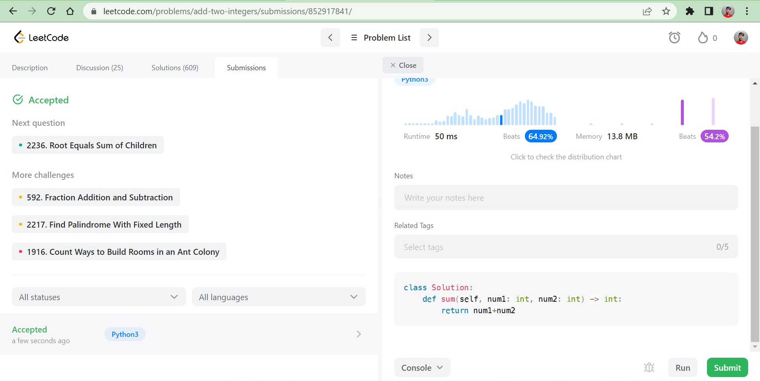

**Time Complexity :** O(1)

**Space Complexity :** O(1)

**Result :** Successfully Executed the Program